IP ADDRESSING AND
SUBNETTING

- List the IP address classes (A, B, C, D, E) and give one real-world example of a device or service that might use each class. Write your answers in a table format.
Answer
IP Address Classes and Real-World Examples
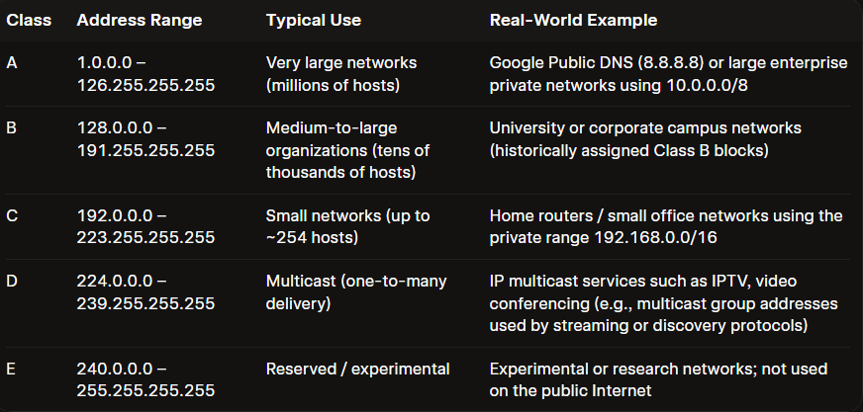
- Given the IP address 192.168.10.45 with subnet mask 255.255.255.0, calculate the network address, broadcast address, and the range of valid host addresses. Show your working steps for each calculation.
Answer
Given IP: 192.168.10.45
Subnet mask: 255.255.255.0 (which is /24)
Step 1: Understand the subnet mask
Subnet mask in binary:
- 255.255.255.0 = 11111111.11111111.11111111.00000000
- First 24 bits = network part
- Last 8 bits = host part
So this is a /24 network.
Step 2: Find the network address
To get the network address, perform a bitwise AND between the IP and the subnet mask.
IP: 192.168.10.45
Mask: 255.255.255.0
- First three octets stay the same (because mask is 255 there).
- Last octet: 45 AND 0 = 0
So:
- Network address = 192.168.10.0
Step 3: Find the broadcast address
Broadcast address = network address with all host bits set to 1.
- Network: 192.168.10.0 → last octet in binary: 00000000
- Set all 8 host bits to 1: 11111111 = 255
So:
- Broadcast address = 192.168.10.255
Step 4: Valid host address range
Valid hosts are all addresses between network and broadcast, excluding both:
- First usable host = network address + 1 = 192.168.10.1
- Last usable host = broadcast address − 1 = 192.168.10.254
So:
- Valid host range = 192.168.10.1 to 192.168.10.254
Final results
- Network address: 192.168.10.0
- Broadcast address: 192.168.10.255
- Valid host range: 192.168.10.1 – 192.168.10.254
- Create a subnetting plan for a small food delivery startup like Zomato that needs 4 separate subnets: one for Delivery Partners, one for Restaurants, one for Customers, and one for Admins. Assign a unique subnet (with network address and subnet mask) for each group using the 10.0.0.0/24 network.
Answer
Here’s a simple /24 → 4-subnet plan using 10.0.0.0/24, split evenly for the four groups.

Subnetting logic (brief)
- Starting network: 10.0.0.0/24 (256 addresses: 10.0.0.0 – 10.0.0.255)
- Need: 4 subnets → borrow 2 bits from the host part
  - 2² = 4 subnets
  - New prefix: /24 + 2 = /26
- Each /26 subnet has:
  - Total addresses: 2^(32−26) = 2^6 = 64
  - Usable hosts: 64 − 2 (network + broadcast) = 62

Subnet plan

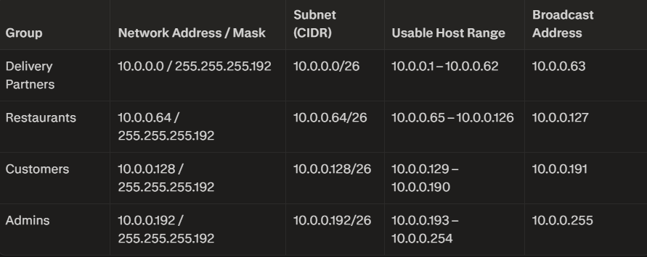
You can now assign:
- Delivery partner devices → 10.0.0.1–10.0.0.62
- Restaurant portals/terminals → 10.0.0.65–10.0.0.126
- Customer-facing services (e.g., Wi-Fi, kiosks) → 10.0.0.129–10.0.0.190
- Admin workstations/servers → 10.0.0.193–10.0.0.254
Each group is isolated in its own subnet while staying within the 10.0.0.0/24 block.

- You are given the following scenario: A college Wi-Fi network uses the IP range 172.16.0.0/16. The admin wants to create at least 20 subnets for different buildings. Calculate the new subnet mask and the number of hosts available per subnet. Show your calculation steps and final answers.
Answer
Given:
- Base network: 172.16.0.0/16
- Requirement: At least 20 subnets
Step 1: Determine how many bits to borrow
We need to find the smallest number of bits $n$ such that:
$$2^{n}≥20$$
- $2^{4}=16$→ too small (only 16 subnets)
- $2^{5}=32$→ sufficient (≥ 20 subnets)
Bits to borrow = 5
Step 2: Calculate the new subnet mask (prefix length)
- Original prefix length = /16
- New prefix length = $16+5=/21$
New Subnet Mask = 255.255.248.0
(Verification: In the third octet, 5 bits set to 1 → 11111000 = 248)
Step 3: Calculate the number of hosts per subnet
- Original host bits = 16
- Host bits remaining = $16-5=11$
Total addresses per subnet:
$$2^{11}=2048$$
Usable hosts (excluding network and broadcast addresses):
$$2048-2=2046$$

Final Answers
Item | Value
New Subnet Mask | 255.255.248.0 (/21)
Number of Hosts per Subnet | 2046 usable hosts

- A friend sends you a message asking why their device with IP 192.168.1.300 is not connecting to the network. Write a short explanation identifying the error and what a valid IP address in that subnet should look like.
Answer
Your device’s IP 192.168.1.300 is invalid, which is why it can’t connect.
In IPv4, each octet (the numbers between the dots) must be between 0 and 255. In 192.168.1.300, the last octet is 300, which is not allowed.
A valid IP in the same subnet (assuming a typical home network with mask 255.255.255.0) would look like:
- Network: 192.168.1.0/24
- Valid host range: 192.168.1.1 to 192.168.1.254
So examples of valid addresses: 192.168.1.10, 192.168.1.50, 192.168.1.200, etc. Change the last octet to any value from 1–254 (and not already in use), and the device should be able to connect.

